COMPUTER NETWORKS

Define Computer Network and its types ?

A computer network is a group of computers linked to each other that enables the computer to communicate with another computer and share their resources, data, and applications.

A computer network can be categorized by their size. A **computer network** is mainly of **four types**:

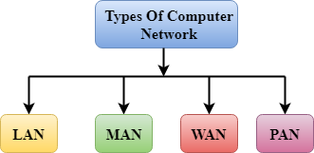

* LAN(Local Area Network)
* PAN(Personal Area Network)
* MAN(Metropolitan Area Network)
* WAN(Wide Area Network)

2 ) Computer Network Architecture ?

Computer Network Architecture is defined as the physical and logical design of the software, hardware, protocols, and media of the transmission of data. Simply we can say that how computers are organized and how tasks are allocated to the computer.

**The two types of network architectures are used:**

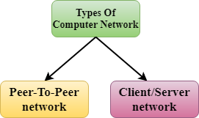

* Peer-To-Peer network
* Client/Server network